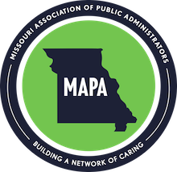

Certification Scholarship Application

Name ____________________________________________________________________
County_______________________________ Years in office_____________________

Scholarship are you applying for:
☐ NCG
☐ NMG

Reason for testing for guardianship certification
(please write your answers on a separate page)

- In what ways will you use your certification?

- How do you feel certification will be helpful to you as a Public Administrator?

- In what roles have you contributed to MAPA?

- What are your long-term plans as a public administrator?

- How many more years do you plan to serve?

Signature _____________________________________________ Date __________________
Email application by Aug 1st to

angiec@jaspercountymo.gov

NCG Certification: MAPA will reimburse the testing fee for one passing NCG certification test per year. The chosen candidate will need to provide the awards committee proof of a passing grade. Candidate will have one year from notification of scholarship award to request reimbursement from MAPA.
NMG Certification: There are two tests for the NMG certification. MAPA will reimburse the testing fees for each passing portion of the NMG certification test per year. The chosen candidate will need to provide the MAPA awards committee proof of a passing grade on each test for reimbursement. Candidate will have one year from notification of scholarship award to request reimbursement from MAPA.

